**05/07/2022:**

**Agenda:**

* What is web Service (or API)?
* Basic Concept behind Web Service
* Why we use it?

**Project Application:**

* Front End(UI)
* Backend(Database)
* Service(API)

**Web Service:**

* Service available over the web
* Waiter: Who is doing communication between you and kitchen
* Waiter: Waiter is performing the role of Web Service through an API
* We can Say he (Waiter) is communicating between two applications and making sure that the communication between two applications is proper.

Kitchen (Chef)(Service Provider)

You (Service Consumer)

Waiter (API)

**Web Service:**

* Service available over the web
* Enables communication between two applications over the web
* Provides a standard protocol/format for communication
* Platform independent communication
* Using Web Services two different applications can talk to each other and exchange data/information.
* An API is the acronym for Application Programming Interface, which is a software intermediary that allows two applications to talk to each other.
* Each time you use an APP like Facebook, send an instant message or check weather on your phone, you are using an API.
* Web Services allows you to expose the functionality of your existing code over the network. Once it is exposed on the network, other applications can use the functionality of your program.

**What is API?**

User Layer or Presentation Layer

Business Layer (API)

Database Layer

Client (Service Consumer)

Server (Service Provider)

Request

Response

Medium: HTTP

Format/language: XML/JSON

**Web Service:**

**Two Types of Web Service:**

* SOAP Service(Simple Object Access Protocol)
* REST Service(Representational State Transfer)

**Components/Specifications/Standards of SOAP Web Service: WSDL, UDDI, SOAP**

**WSDL: Web Service Description Language:** [**http://www.dneonline.com/calculator.asmx?WSDL**](http://www.dneonline.com/calculator.asmx?WSDL)

* WSDL stands for web service description language
* WSDL is the standard format for describing a web service
* WSDL is pronounced as ‘wiz-dull’ and spelled out as W-S-D-L
* WSDL definition describes how to access a web service and what operations it will perform.
* WSDL is often used in combination with SOAP and XML
* A Client program connecting to a web service can read the WSDL to determine what functions are available on the server.
* WSDL is an XML based document with a <definitions> element at the root and the child elements

<types>,

<message>,

<portType>,

<binding>

* Web Service description language is an XML based interface that is used to describe the functionalities of the web service

<definitions>:

* Element must be the root element of all WSDL documents
* It defines the name of the web service
* The definitions element is the container of all the other elements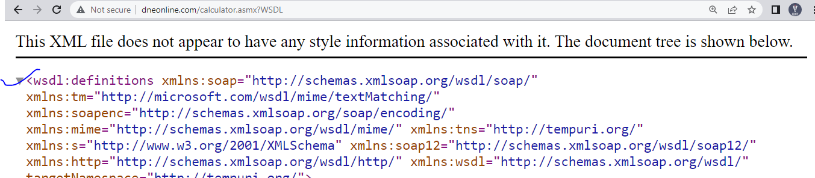

<types>:

* WSDL <types> element takes care of defining the data types that are used by the web service
* WSDL allows the types to be defined in separate elements so that the types are reusable with multiple web service

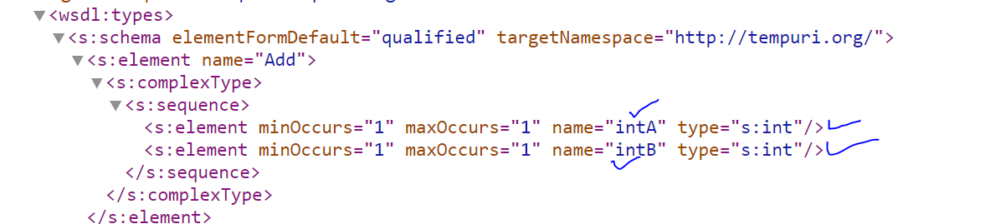

<Message>:

* The <message> element describes the data being exchanged between the web service provider and consumers.
* Each Web Service has two messages: Input and Output.

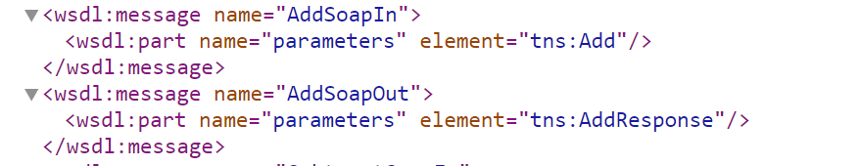

<portType>:

* <portType> can combine one request and one response message into a single request response operation. 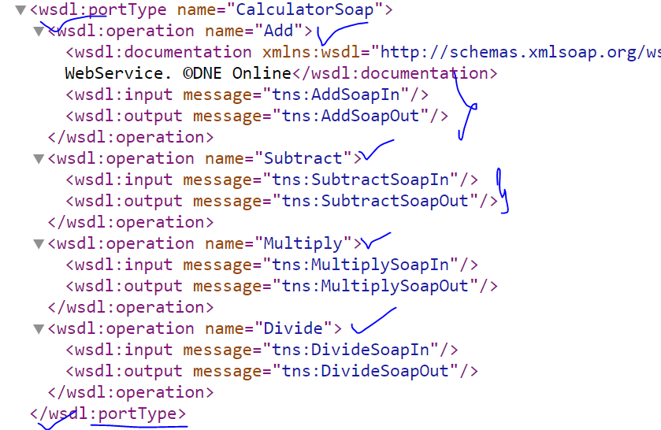

<binding>:

* To Combine all operations together
* The <binding> element provides specific details on how a port type operation will actually be transmitted over the web. 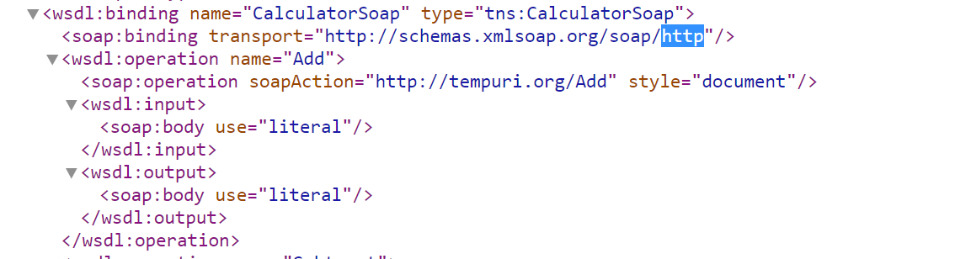

WSDL File/Service: <defintions>,<types>,<message>,<portType>,<binding>

**UDDI: Universal Description Discovery Integrations**

* Universal description discovery integration is an XML based standard for publishing and finding web services
* A web service provider publishes his web service(through WSDL) on an online directory from where consumers can query and search the web service
* This is online registry/directory

WSDL

WSDL

WSDL

WSDL

UDDI

# API Testing-

* 2 Types Service

1. SOAP service(SOAP UI tool)
2. REST service(SOAP UI,POSTMAN)

Paytm – UI/ GUI

**Service Travels**- Parameter Values

Travels agency/ Provide-**Service/**

**IRCTC - Service**

Request

Response

IRCTC main Server